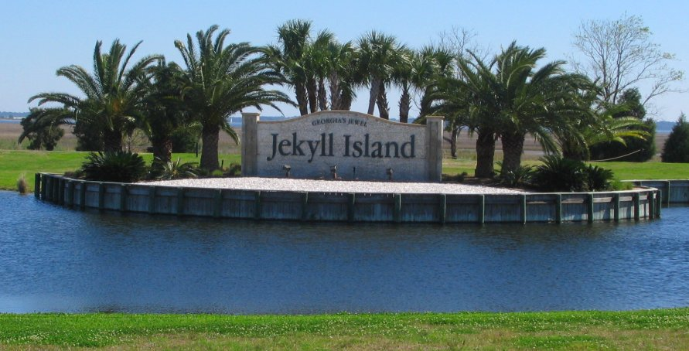
Georgia Association of School Psychologists
2017 Fall Conference
“Beyond Assessment: School Psychologists as Teachers, Counselors, and Leaders”
The Westin Jekyll Island
October 16-18, 2017
Featuring:
Christian Moore
Keynote Speaker
Founder of the WhyTry and Resilience Breakthrough for Youth Programs, and author of The Resilience Breakthrough: 27 Tools for Turning Adversity into Action.

Other distinguished presenters include Dr. Ray DeGiuseppe, Dr. Nancy Mather, Dr. George McCloskey, Dr. Peter Isquith, Dr. Maggie Kjer, Dr. Catherine Perkins, and many more!
Special thanks to our generous speaker sponsors: MHS, HM Harcourt, PAR, Pearson, and Schoolhouse Educational Services

