Georgia Association of School Psychologists, Region 5
& Jackson County School System present:
Reading and Dyslexia: An Expert Panel Discussion

Panel Members: Jennifer H. Lindstrom, Ph.D., Associate Professor of Special Education, University of Georgia
Maggie Kjer, Ph.D., Director, Clinical Solutions Analyst, Pearson
Catherine Perkins, Ph.D., Clinical Associate Professor, Georgia State University
Margaret Camp, Ph.D., Clinical Assessment Consultant, Riverside Insights

Topics Include: Senate Bill 48, Current Dyslexia/Reading Research, Instructional Practices, Assessment Tools, Evaluation Methods, Interventions, and More!

Time/Date: 9:00 a.m. - Noon
Friday, December, 13 2019
Earn PLU/CEU Credit
GASP is a NASP-Approved Provider
Location: The Jefferson Clubhouse
302 Longview Drive
Jefferson, GA 30549
Cost: Free for GASP Members;
$10 for non-GASP Members
RSVP: By December 2, 2019 by submitting your completed
Registration Form (and payment, if applicable) to Rachel Greenlee

****Light refreshments will be provided****
REGISTRATION FORM
Event: GASP Region 5 Presents Reading and Dyslexia: An Expert Panel Discussion

Friday, December 13, 2019
9:00 a.m. – Noon
The Jefferson Clubhouse
302 Longview Drive
Jefferson, GA 30549

Name:___________________ Job Title:_____________________
Address:_________________ City:________ State:___ Zip:_____
Email:___________________ Place of Employment:____________

GASP Member: Yes (Free) No ($10 Enclosed)

Registration Deadline is: December 2, 2019. GASP members may submit this completed registration form by December 2, 2019 via e-mail to rgreenlee@jcss.us or mail. Non-GASP members, submit this completed registration form along with payment by mail.
Cash or Check only. Please make checks payable to GASP.

----------------------------------------------------------------------------------------

Mail To: Rachel Greenlee
Gum Springs Elementary School
600 Gum Springs Church Road
Jefferson, GA 30549

Contact Rachel Greenlee with questions or concerns
Email: rgreenlee@jcss.us Office: 706-387-2051

This workshop provides NASP-approved CPD credits for school psychologists. GASP is approved by the National Association of School Psychologists.
GASP maintains responsibility for the program and its content.
EVENT LOCATION

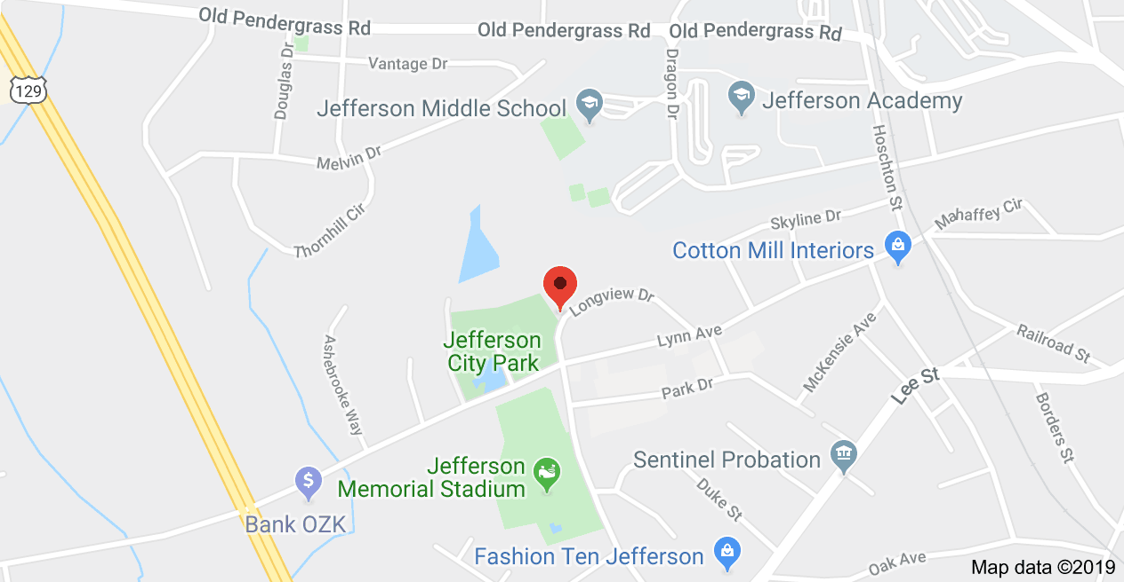

The Jefferson Clubhouse
302 Longview Drive
Jefferson, GA 30549

